**Design 3 - Storytelling**

Jette Korthals Altes, Steven Kuhnen, Sylvie Langhout, Lucas Lumeij, Marieke van Maanen

**Introduction**

*“There are surprisingly few discussions of the link between wellbeing and alcohol, and few empirical studies to underpin them. Policymakers have therefore typically considered negative wellbeing impacts while ignoring positive ones”* Research by Geiger and MacKerron (2016) has shown that alcohol can have a positive effect on the wellbeing of individuals. The Happy Planet Index includes wellbeing, so we plotted wellbeing per country to its alcohol consumption.

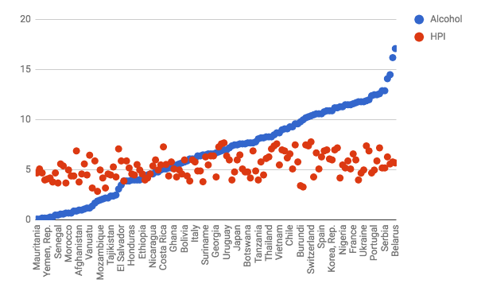

There does not seem to be a correlation between alcohol consumption and wellbeing. And indeed, Geiger and MacKerron (2016) propose that the different ways of alcohol consumption deserve more attention from policy makers, instead of the total alcohol consumption.

Therefore, we are going to zoom in on 3 countries with very similar alcohol consumption, but score differently on wellbeing: Hungary, Slovakia, and Australia.

We will look at alcohol dependency and alcohol disorders, the prevalence of heavy, episodic drinking, and types of alcoholic beverages.

Hungary gets a 4.7 on wellbeing, the lowest of the three selected countries.. 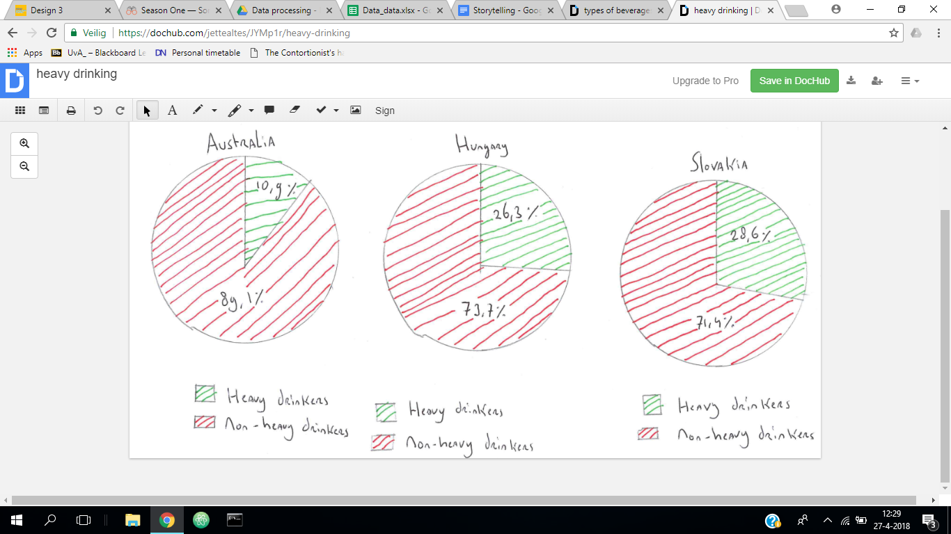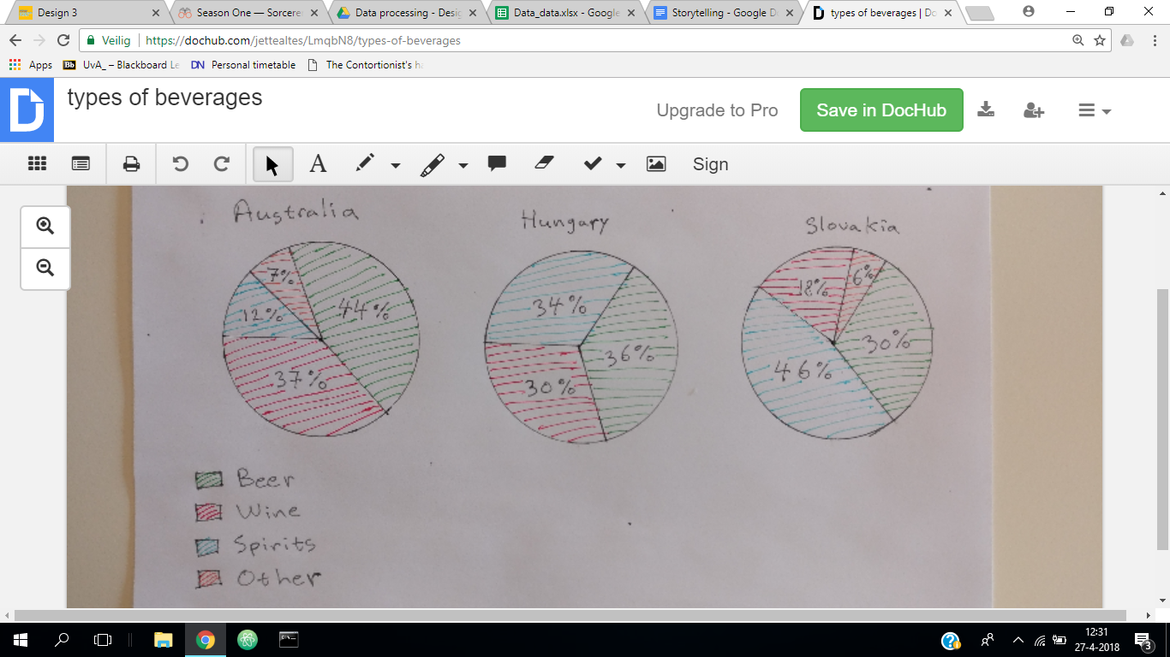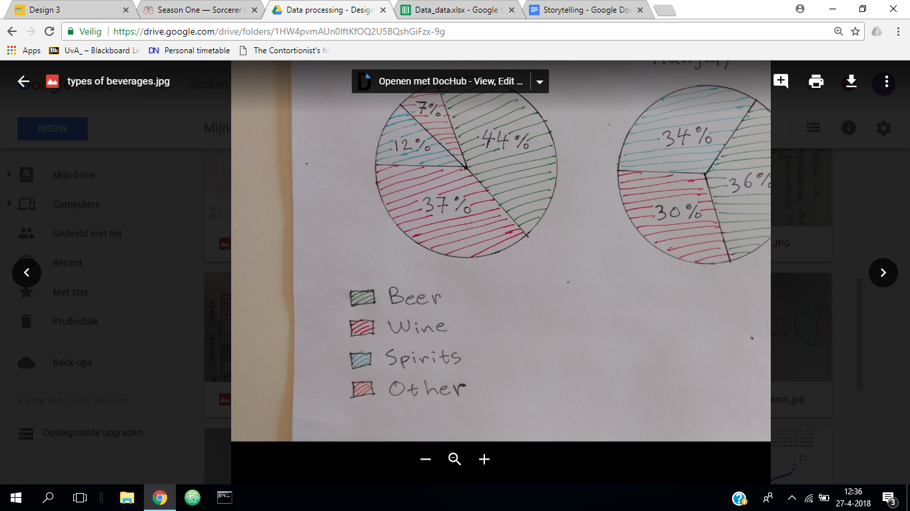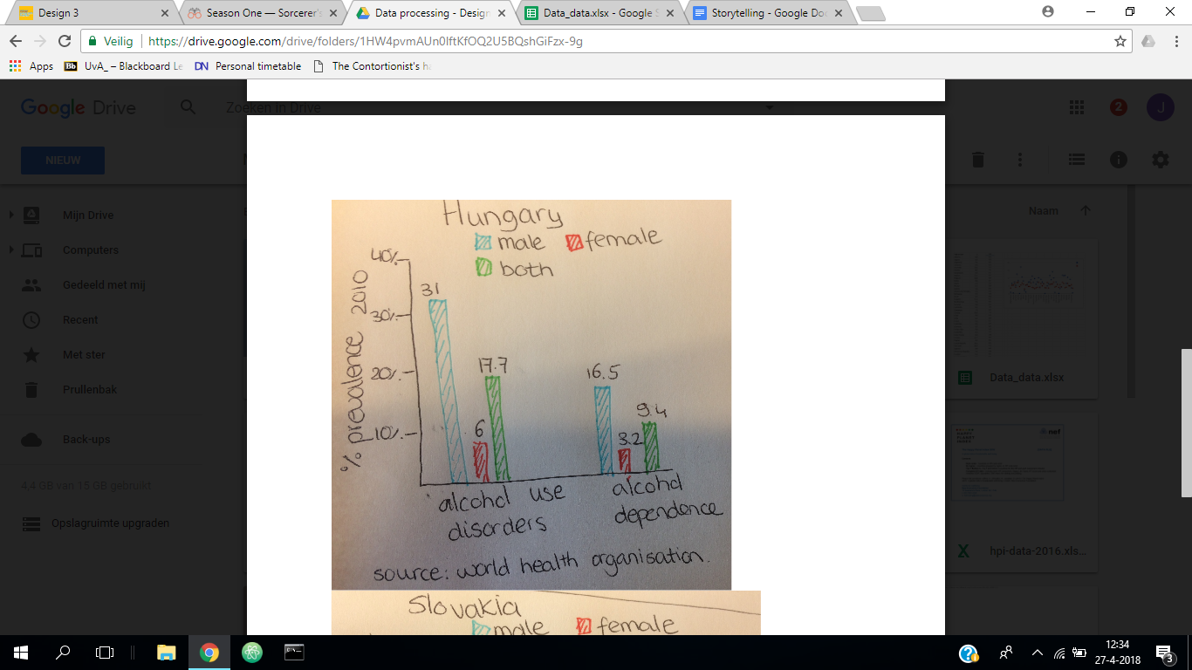

Slovakia scores a 5.9 on wellbeing.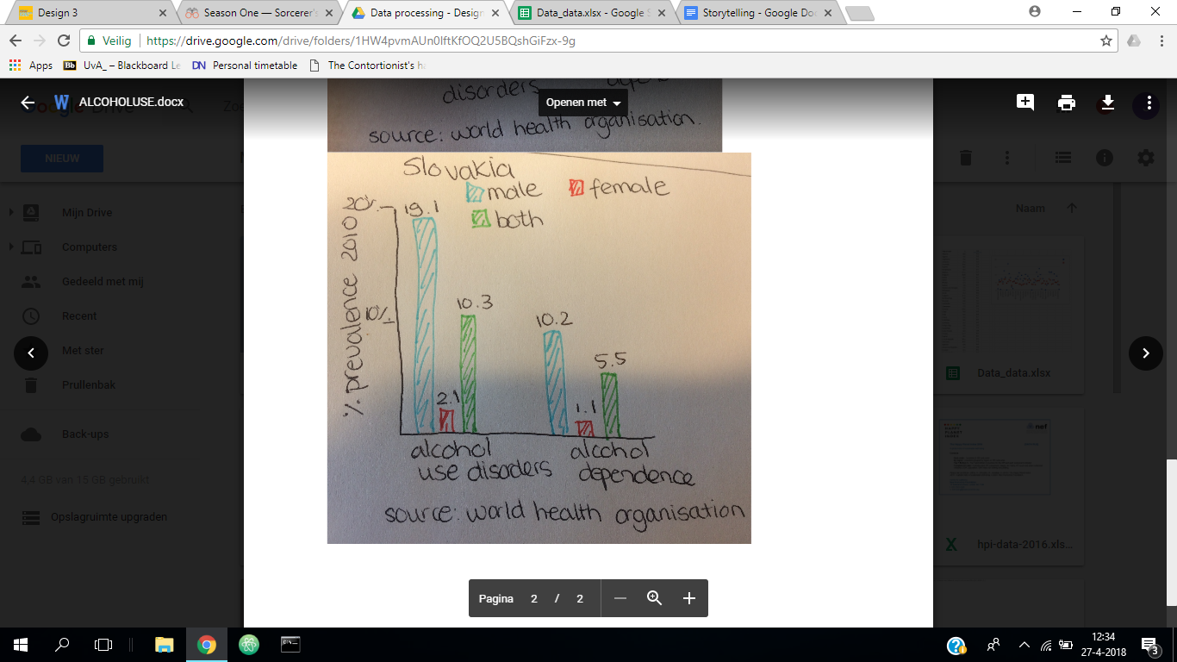

Australia scores a 7.2 on wellbeing, the highest of the selected countries.



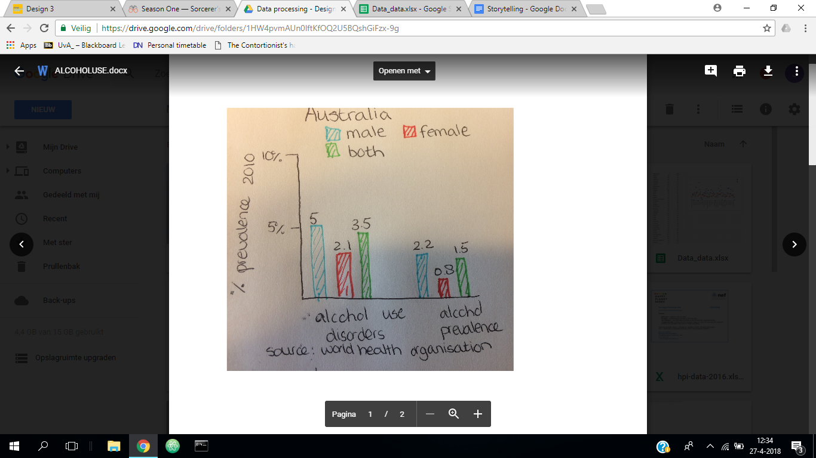

Let’s compare.

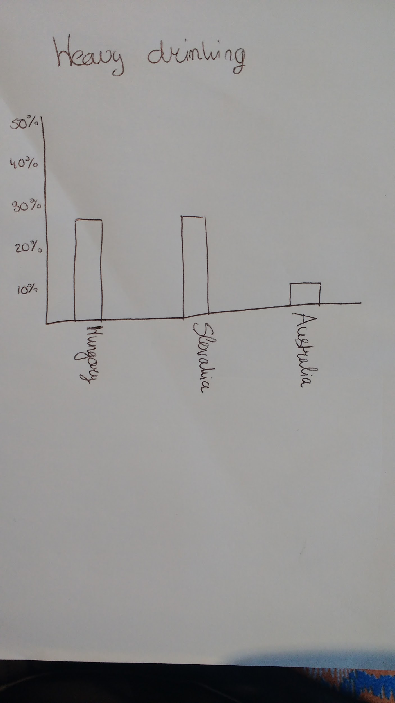 For the percentage of drinkers that are heavy drinkers,the difference between Hungary and Slovakia is pretty small, but the percentage of Australia’s drinking population is half the size of that of Hungary and Slovakia.

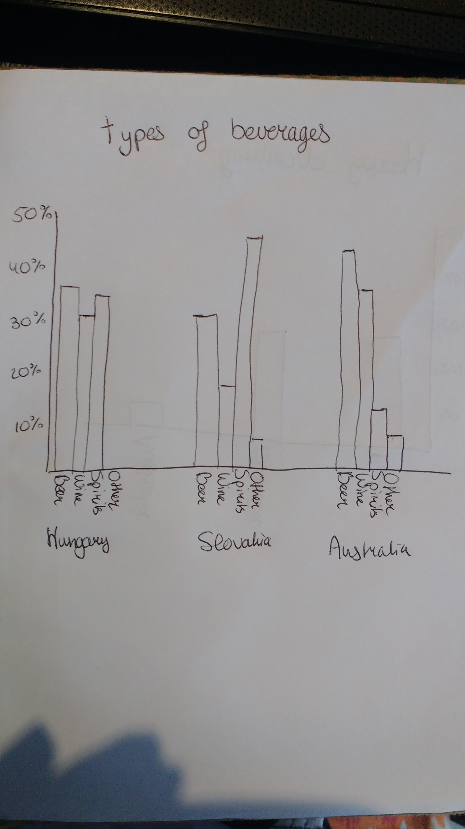As the country scores higher on wellbeing, the mysterious “other” beverage comes into place. Is that the secret of happiness?

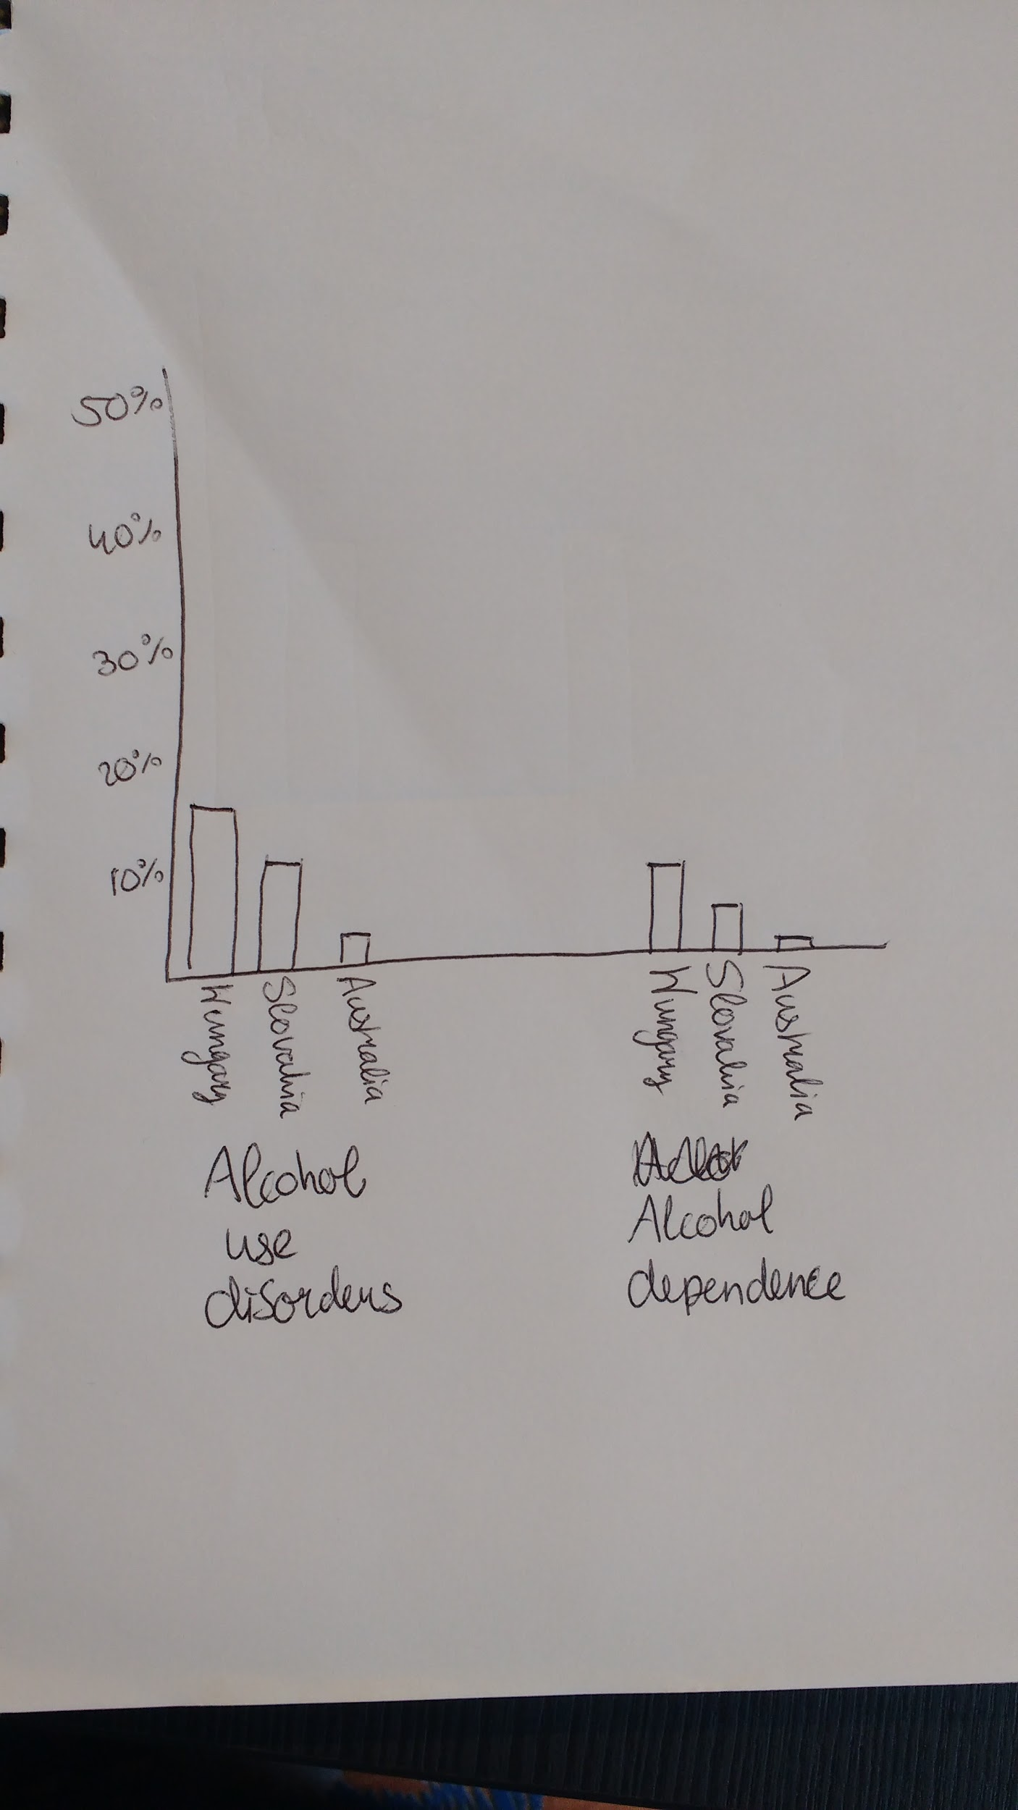 Finally, something that looks like a correlation! As both the prevalence of alcohol use disorders and alcohol dependence shrinks, the wellbeing score grows.

There does not appear to be a link between wellbeing and the amount of drinking, or wellbeing and the type of alcoholic beverage, as long as you don’t become dependent. Good news for all us students ;)

Geiger, B. B., & MacKerron, G. (2016). Can alcohol make you happy? A subjective wellbeing approach. *Social Science & Medicine*, *156*, 184-191.